Research paper on Aquatic Animal Detection with OpenCV

## Abstract
The aim of paper this is to use OpenCV for aquatic animal detection and its potential contribution to marine life research and conservation. By employing image preprocessing, feature extraction, and deep learning models, the proposed system aims to detect and classify various aquatic species in underwater images and videos. The methodology involves- Preprocessing, Feature Extraction, Deep Learning Model Development, Evaluation and Optimization. The paper further discusses existing object detection systems like YOLO, Faster R-CNN, SSD, and RetinaNet, highlighting their strengths and limitations. Additionally, it presents a step-by-step guide on using YOLO V8 for object tracking in Python, showcasing its implementation and results. Finally, the paper concludes by emphasizing the potential of OpenCV-based aquatic animal detection for marine research and conservation efforts, highlighting its advantages in real-time object detection and its generalizability to new domains.

## Introduction
Computer vision technology opened a wide range of opportunities for automated detection and recognition of objects in images and videos. Using OpenCV for Aquatic animal detection presents a unique opportunity to contribute to marine life research and environmental conservation. By employing advanced image processing techniques and machine learning algorithms, we can not only detect and recognize aquatic animals in underwater images but also track their movements and behaviours. This method can help watch and save endangered sea animals, helping to protect the underwater environment.
Furthermore, the data collected through this project can provide valuable insights into the behaviours and distribution of aquatic animals, allowing for informed decision-making in marine conservation efforts. By using the power of computer vision technology, we can surely expand our understanding of the complex interactions within the underwater environment, leading to more effective strategies for preserving the biodiversity of our oceans. Our project aims to develop an aquatic animal detection system using OpenCV, an open-source computer vision library. Our system will involve processing underwater video footage or images and training a deep-learning model to detect and classify different species of aquatic animals.
To use object detection using Python and OpenCV, we must follow these steps:
- Install OpenCV: BY using package managers like pip to install the necessary dependencies.
- Load the video/image: Use OpenCV to load the video or image as you want to perform.
- Select any object detection algorithm: Such as SSD (Single Shot MultiBox Detector), YOLO (You Only Look Once), Fast R-CNN etc.
- Implementing the object detection algorithm
- Detect objects: Execute the object detection algorithm on your input video or image data. The algorithm will analyze the video frame or image and detect the object.

## Methodology
To accomplish the goal of aquatic animal detection with OpenCV, adopt a multi-step methodology that includes image preprocessing, feature extraction, and deep learning model development.
- Image Preprocessing
Beginning with the preprocessing of the underwater images or the underwater video frames to enhance the quality and contrast of the visuals. This may involve techniques such as noise reduction, colour correction, and contrast refinement to improve the clarity of the aquatic animal features in the images.
- Feature Extraction
After the preprocessing of images, extract relevant features from the aquatic animal images by using the image processing functions of OpenCV. These features may include the shape, texture, and colour patterns characteristic of different aquatic animal species.
- Deep Learning Model Development
Next, develop a deep learning model by using a deep neural network module of OpenCV to classify and detect the aquatic animals based on the extracted features. The model will be trained on a labelled dataset of aquatic animal images to learn how to distinguish between different species.
- Evaluation and Optimization
After training the model, evaluate its performance using indicators such as precision, recall, and accuracy. Now iterate on the model architecture and parameters to enhance its performance in detecting a wide variety of aquatic animal species with high accuracy.
Following this comprehensive methodology, the objective is to create a resilient aquatic animal detection system that can assist marine life research and conservation efforts.

## Related Technology

Object detection is a computer vision task that involves identifying and locating objects within an image or video. There are several existing systems and frameworks for object detection, mentioning a few prominent ones as of my last knowledge update in January 2022. Keep in mind that new developments may have occurred since then.

- YOLO (You Only Look Once): YOLO is a real-time object detection system that divides an image into a grid and predicts bounding boxes and class probabilities for each grid cell. YOLO versions include YOLOv1, YOLOv2 (YOLO9000), YOLOv3, YOLOv4, and YOLOv8 each introducing improvements in accuracy and speed.

- Faster R-CNN (Region-based Convolutional Neural Network): Faster R-CNN is a two-stage object detection framework. It first proposes potential bounding box regions and then classifies objects within those regions. It uses a Region Proposal Network (RPN) to generate region proposals and a classifier to predict class labels and refine bounding box coordinates.

- SSD (Single Shot MultiBox Detector): SSD is a single-shot object detection framework. It simultaneously predicts multiple bounding boxes and their corresponding class scores in different scales. It uses multiple convolutional feature maps at different resolutions for detection at various scales.

- RetinaNet: RetinaNet is known for addressing the problem of class imbalance in object detection by introducing the Focal Loss. It uses a Feature Pyramid Network (FPN) to capture multi-scale features and achieve accurate and efficient object detection.

- Mask R-CNN: This is an extension of Faster R-CNN, Mask R-CNN which adds branch to predict segmentation masks for each instance in addition to bounding box and class predictions. It is commonly used for tasks that require pixel-level accuracy, such as instance segmentation.

- EfficientDet: EfficientDet is an efficient and accurate object detection model that optimizes the trade-off between model accuracy and computational efficiency. It uses compound scaling to balance model size and accuracy, achieving good performance on various devices.
These systems often leverage deep learning frameworks like TensorFlow, PyTorch, or others for implementation and training on large datasets. Keep in mind that the field of object detection is dynamic, and newer models or improvements may have been introduced since my last update.

## How does it work
Using YOLO V8 for object tracking in Python. Setting up the Python project and installing requirements. Loading the YOLO V8 model for object detection and tracking. Loading and reading frames from the video. Detecting and tracking objects using YOLO V8. Plotting the results on the frame. Visualizing the results in real-time. The video used for testing contains a turtle and a fish, and the model is trained on the COCO dataset, which include 4 different object classes. The Ultralytics package is required for this project and can be installed using pip. The project involves- train and loading the YOLO V8 model, loading the video, reading frames, applying object detection and tracking, plotting the results, and visualizing them in real-time. The code includes step-by-step explanations and is written in Python using VScode. The results include bounding boxes around the detected objects and unique IDs for tracking. It provides an alternative method using cv2.rectangle and cv2.putText for plotting the results.

##Architecture
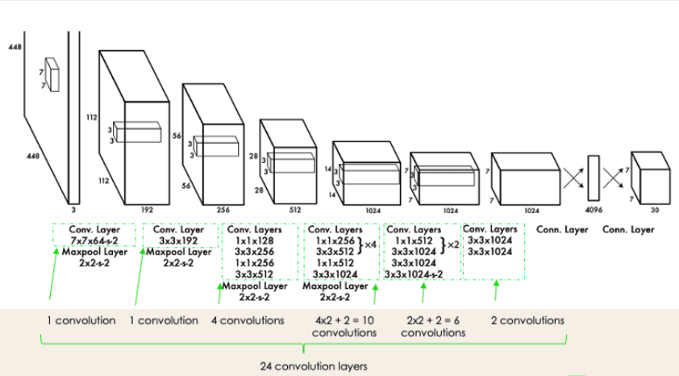
YOLO architecture from the original paper

##Result

The input video is broken down into individual frames. Every frame represents a single image. Then, the image is divided into a grid of cells. This allows for localized predictions, also reduces computational complexity, and predicts bounding boxes that encompass objects in the image. Each bounding box is described by a vector containing attributes such as the probability of containing an object, coordinates of the box's center, dimensions of the box, and class probabilities. Multiple cells in grid may overlap with the same object. Intersection Over Union (IOU) calculates the overlap between predicted bounding boxes and ground truth boxes. Even after using IOU multiple bounding boxes for the same object can remain. Non-Maximum Suppression (NMS) suppresses redundant bounding boxes, retaining only the highest probability detections. With the help of NMS noise is eliminated and ensured that each object is represented by only one bounding box. Here are some outputs from the experiment:

##Conclusion

This paper explored the use of OpenCV for aquatic animal detection, showcasing its potential in marine research and conservation. Through image preprocessing, feature extraction, and deep learning model development, we aimed to detect and classify aquatic species. Existing object detection systems like YOLO, Faster R-CNN, SSD, and RetinaNet were discussed, along with a practical guide on using YOLOV8 for object tracking. The methodology provided a detailed plan to create a strong detection system. By leveraging computer vision technology, particularly OpenCV, we can contribute significantly to the monitoring and protection of marine life, ultimately preserving the delicate underwater ecosystem.

##Acknowledge

In closing, we extend our heartfelt gratitude to Ms. Manisha Verma for her invaluable guidance and supervision in shaping our research paper. Her expertise and support have been instrumental. We are deeply appreciative of her mentorship, which has significantly enriched our work and contributed to our academic growth.

##Reference

- Nikitha, P., T. Nikitha, M. Nikshitha, T. Nikhil, T. Nithin, K. Nithish Reddy, and Sanjaykumar J. Hamilpure. "OBJECT DETECTION USING OPENCV WITH PYTHON."
- Redmon, Joseph, Santosh Divvala, Ross Girshick, and Ali Farhadi. "You only look once: Unified, real-time object detection." In Proceedings of the IEEE conference on computer vision and pattern recognition, pp. 779-788. 2016.
- To train YOLOv8 the source of dataset: https://universe.roboflow.com/tetra/tetra_marine/dataset/1
- Source of video used in this paper for output: https://youtu.be/5Rmv3nliwCs?si=lR89PsVjTLiJpeTh

